

2026 LEADER OF THE PACK TOURNAMET RESULTS

Women - 103
  - Guaranteed Places

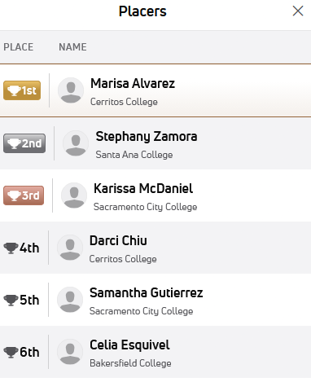 click for full bracket

Women - 110
  - Guaranteed Places
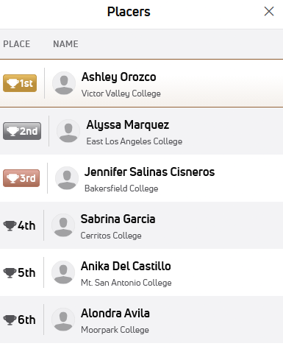

Click for full bracket

Women - 117
  - Guaranteed Places
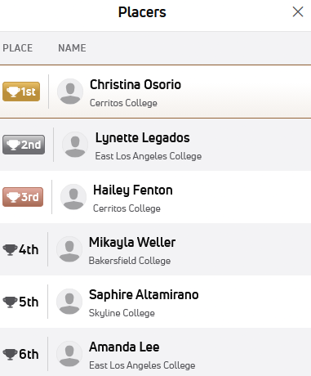Click for full bracket

Women - 124
  - Guaranteed Places
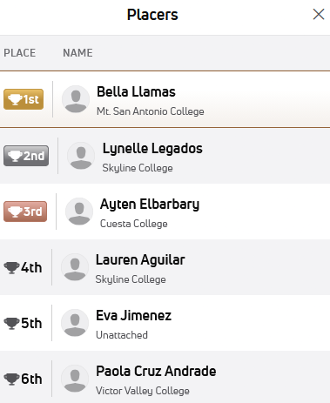Click for full bracket

Women – 131
  - Guaranteed Places

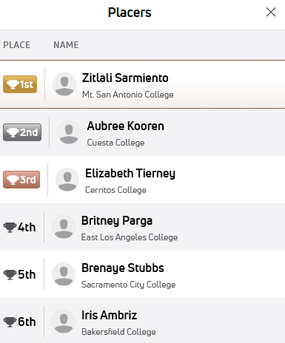Click for full bracket

Women - 138
  - Guaranteed Places
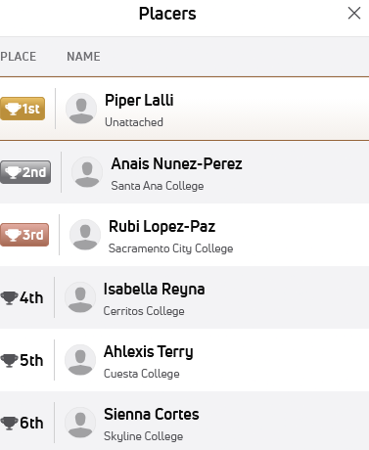Click for full bracket

Women - 145
  - Guaranteed Places
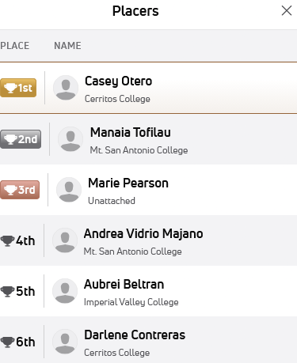Click for full bracket

Women - 160
  - Guaranteed Places

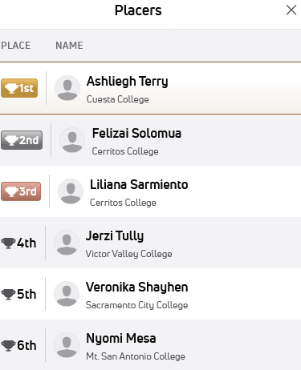Click for full bracket

Women - 180
  - Guaranteed Places

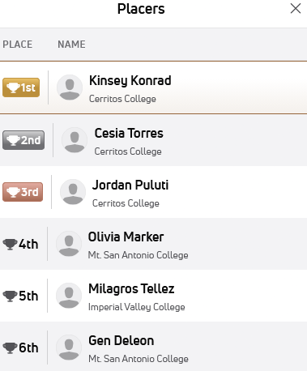Click for full bracket

Women - 207
  - Guaranteed Places

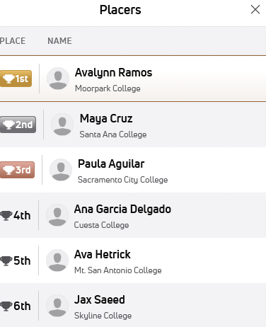 Click for full bracket

Women - 235
  - Guaranteed Places
