
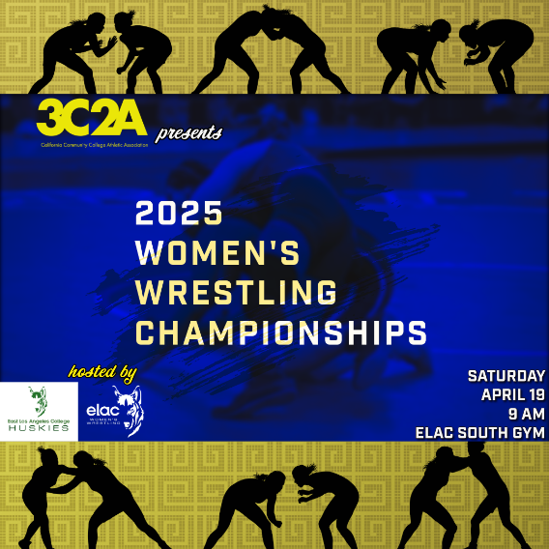

3C2A Women’s State Championships Results for
East Los Angeles College

110
Kaitlyn Moreno (3-7) place is unknown and scored 0.0 team points.
- Champ. Round 1 - Ciara Hawkins (Santa Ana College) 3-2 won by fall over Kaitlyn Moreno (East Los Angeles College) 3-7 (Fall 1:56)
- Cons. Round 1 - Tiffany Yanagi (Mt. San Antonio College) 5-1 won by tech fall over Kaitlyn Moreno (East Los Angeles College) 3-7 (TF-1.5 2:07 (12-2))

117
Mollie Jimenez (7-10) placed 7th and scored 6.0 team points.
- Champ. Round 1 - Mollie Jimenez (East Los Angeles College) 7-10 received a bye () (Bye)
- Quarterfinal - Lailanie Vongnakhone (Fresno City College) 3-1 won by fall over Mollie Jimenez (East Los Angeles College) 7-10 (Fall 5:38)
- Cons. Round 2 - Mollie Jimenez (East Los Angeles College) 7-10 received a bye () (Bye)
- Cons. Round 3 - Evelin Cerda (Santa Rosa College) 1-3 won by fall over Mollie Jimenez (East Los Angeles College) 7-10 (Fall 2:12)
- 7th Place Match - Mollie Jimenez (East Los Angeles College) 7-10 won by fall over Ivana Boulter (Palomar College) 1-3 (Fall 1:50)

124
Haely Lemus (16-7) placed 2nd and scored 19.0 team points.
- Champ. Round 1 - Haely Lemus (East Los Angeles College) 16-7 received a bye () (Bye)
- Quarterfinal - Haely Lemus (East Los Angeles College) 16-7 won by fall over Paola Cruz Andrade (Victor Valley) 4-10 (Fall 0:26)
- Semifinal - Haely Lemus (East Los Angeles College) 16-7 won by fall over Denise Figueroa (Cerritos College) 2-3 (Fall 2:14)
- 1st Place Match - Leilani Lazaro (Mt. San Antonio College) 4-0 won by tech fall over Haely Lemus (East Los Angeles College) 16-7 (TF-1.5 4:03 (14-4))

131
Raylene Guzman (2-12) place is unknown and scored 2.5 team points.
- Champ. Round 1 - Rontaysia Payne (Cerritos College) 3-1 won by tech fall over Raylene Guzman (East Los Angeles College) 2-12 (TF-1.5 0:30 (10-0))
- Cons. Round 1 - Raylene Guzman (East Los Angeles College) 2-12 won by fall over Taeghan Golembiesky (Victor Valley) 1-12 (Fall 2:00)
- Cons. Round 2 - Sierra Whaling (Sacramento City College) 2-3 won by fall over Raylene Guzman (East Los Angeles College) 2-12 (Fall 0:33)

145
Bella Arredondo (9-9) placed 7th and scored 10.5 team points.
- Champ. Round 1 - Bella Arredondo (East Los Angeles College) 9-9 won by tech fall over Shannon Clearly (Skyline) 1-3 (TF-1.5 4:07 (10-0))
- Quarterfinal - Saquoia Dubuque (Cerritos College) 3-1 won by fall over Bella Arredondo (East Los Angeles College) 9-9 (Fall 2:14)
- Cons. Round 2 - Bella Arredondo (East Los Angeles College) 9-9 won by tech fall over McKenna Gridley (Fresno City College) 0-3 (TF-1.5 2:00 (10-0))
- Cons. Round 3 - Jasmine Vo (Santa Rosa College) 3-2 won by fall over Bella Arredondo (East Los Angeles College) 9-9 (Fall 1:02)
- 7th Place Match - Bella Arredondo (East Los Angeles College) 9-9 won by fall over Shannon Clearly (Skyline) 1-3 (Fall 2:45)

180
Jennifer Contreras (4-7) placed 8th and scored 3.0 team points.
- Champ. Round 1 - Jennifer Contreras (East Los Angeles College) 4-7 received a bye () (Bye)
- Quarterfinal - Isabella Pacheco (Cerritos College) 3-2 won by fall over Jennifer Contreras (East Los Angeles College) 4-7 (Fall 0:21)
- Cons. Round 2 - Jennifer Contreras (East Los Angeles College) 4-7 received a bye () (Bye)
- Cons. Round 3 - Blanca Aleman (Fresno City College) 4-3 won by fall over Jennifer Contreras (East Los Angeles College) 4-7 (Fall 1:37)
- 7th Place Match - Paula Aguilar (Sacramento City College) 2-2 won by forfeit over Jennifer Contreras (East Los Angeles College) 4-7 (For.)

235
Behnaz Agahzade (6-2) placed 3rd.
- Quarterfinal - Behnaz Agahzade (East Los Angeles College) 6-2 won by fall over Illiana Serrano (Lassen) 0-2 (Fall 0:47)
- Semifinal - Eniekeye Osede (Cerritos College) 2-0 won by fall over Behnaz Agahzade (East Los Angeles College) 6-2 (Fall 3:20)
- Cons. Semi - Behnaz Agahzade (East Los Angeles College) 6-2 received a bye () (Bye)
- 3rd Place Match - Behnaz Agahzade (East Los Angeles College) 6-2 won by tech fall over Keyscha Rodriguez (Cerritos College) 1-2 (TF-1.5 4:39 (13-3))

