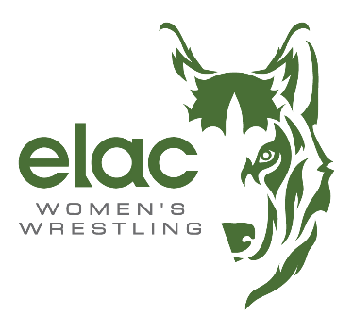

2025 LEADER OF THE PACK TEAM SCORES

 | Team | Abbr | Score
1 | Mt. San Antonio College | MSAC | 84.0
2 | Skyline | SKY | 72.5
3 | San Joaquin Delta | SJD | 58.5
4 | East Los Angeles College | ELAC | 55.5
5 | Santa Ana College | SA | 52.5
6 | Palomar College | PAL | 38.5
7 | Fresno City | FC | 33.0
8 | Bakersfield College | BAK | 32.0
9 | Cerritos College | CC | 31.5
10 | Sacramento City College | SCC | 30.0
11 | Victor Valley College | VV | 23.5
12 | Moorpark | MP | 3.0
13 | Coll. of the Redwoods | REDW | 0.0
14 | Cuesta College | CUE | 0.0
15 | Lassen College | LASS | 0.0
16 | Menlo College | MEN | 0.0
17 | Santa Rosa Junior College | SRJC | 0.0

